## horizontal line

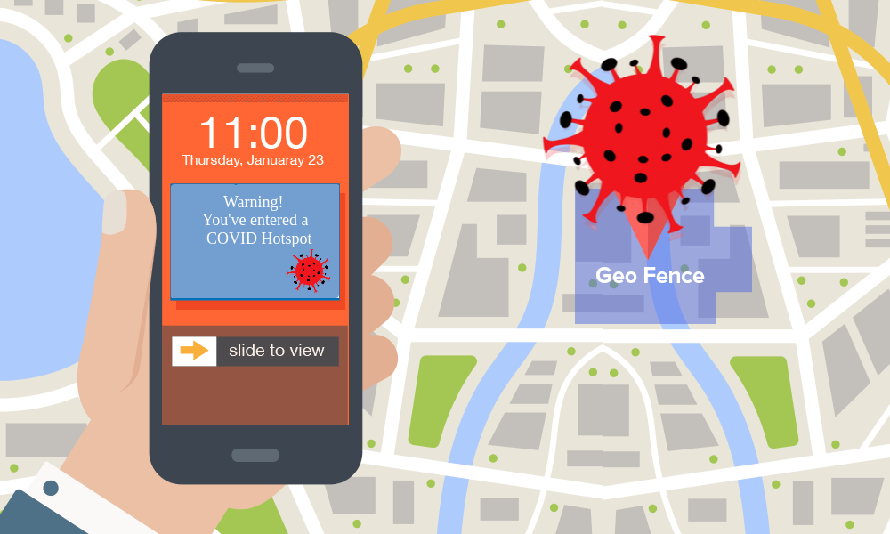

Title of the Project:

Geofencing COVID-19 Hotspots

# 

# 🔗 Introduction

Our country has now entered the community transmission phase of the COVID-19 pandemic, thus forming major hotspots in various regions of affected cities. Despite the policy of lockdown and curfews, people often need to venture out from their homes for their essential needs and they may get the disease too if they fall into such clusters or come very close to a possible carrier of the disease. Till now a properly maintained and updated database of such clusters doesn’t exist for people to monitor nearby hotspots.

# 📌 Objective

# We look forward to create and maintain a cloud database of the locations of COVID-19 infected residences and cluster nearby instances into COVID-19 hotspots. These hotspots stored in the database are used to deploy virtual geofences throughout the city. A person gets notified whenever he/she enters/exits a hotspot.

# 💡 Benefits

* Realtime COVID-19 hotspots throughout the city.
* Instant notifications when entering/exiting a hotspot.
* Monitor nearby COVID-19 hotspots with active case count inside them.

# ⚙️ Working

1. **User Side Mobile Application** 📱👥
   1. As the app is launched, an internal request is sent by the Google Maps API, and displays the user’s current location on the map.
   2. Now it connects to the remote database to get COVID-19 clusters and possible individual carriers in the current city and displays them on the map.
   3. The app then monitors the distance between the user’s location and the center of the nearest geofence. In case the user enters a geofence, it notifies the user with a message - “*You Are Not Safe*”. When he/she comes out of the hotspot, it notifies - “*You Are Safe*”.

The flow chart on the next page shows the working of the user side application:

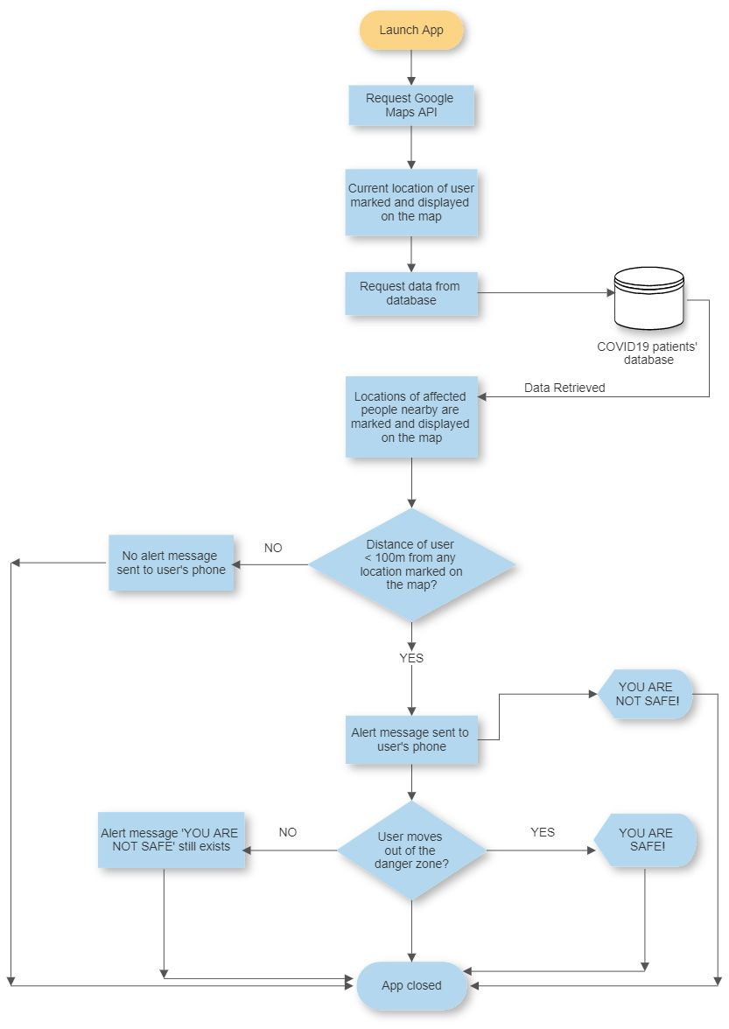

1. **Server Side 🖥️ 👨‍💻**
   1. Whenever new cases are reported, details of the patient and coordinates of the place are updated to the database
   2. A clustering algorithm is then deployed (e.g. K Means Clustering) which clusters nearby cases and groups them into common hotspots.

The plot given below displays the raw data of the coordinates of 60 virtual COVID cases reported in our city.

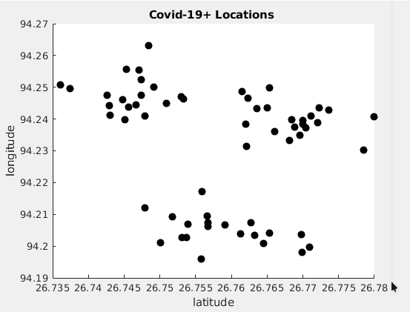

These raw cases are to be processed with an efficient clustering algorithm which groups nearby cases and reduces them to a single case at the center of a geofence with a radius enough to cover up all the cases of the same cluster. The next plot shows the cases grouped into 3 clusters:

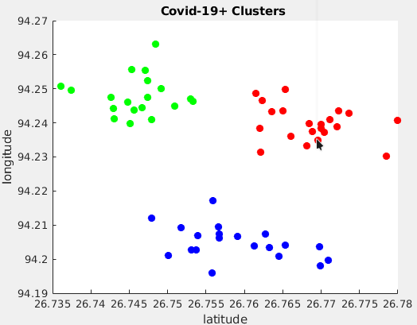

* 1. These hotspots are uploaded to the database and geofences are updated according to these hotspots

The map below shows the 60 cases enclosed by geofences. The user application monitors the user’s position relative to these geofences and acts accordingly.

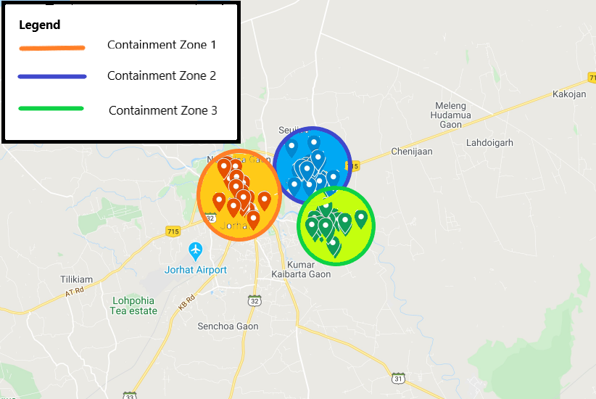

* 1. The flowchart below illustrates the working of the server side of the project:

database

fetch data

new data

clustering algorithm

update database

API Request

Request

Acknowledgement

**Cost of the Project**

The cost of the project can be broken down as follows:

|  |  |  |
| --- | --- | --- |
| **Serial Number** | **Description** | **Amount** |
| 1 | Play store developer charges | $25 (~1889 INR) * |

*The fee is not applicable if a play store developer account is available.

**📋Group Members**

1. Aritra Kaushik : 4th Semester, Computer Science & Engineering, Jorhat Engineering College
2. Bhaskar Jyoti Bhattacharya : 4th Semester, Computer Science & Engineering, Jorhat Engineering College
3. Pijush Bhuyan : 4th Semester, Computer Science & Engineering, Jorhat Engineering College
4. Souvik Baruah : 4th Semester, Computer Science & Engineering, Jorhat Engineering College

**📞Contact No.**

1. Aritra Kaushik : +91-7874584945
2. Bhaskar Jyoti Bhattacharya : +91-9127305615
3. Pijush Bhuyan : +91-7086694512
4. Souvik Baruah : +91-6000032840

**📩Email Addresses**

1. Aritra Kaushik : aritra.kaushik@gmail.com
2. Bhaskar Jyoti Bhattacharya :bhaskarbhattacharya5@gmail.com
3. Pijush Bhuyan : pijush.bhuyan@gmail.com
4. Souvik Baruah : baruahsouvik@gmail.com